**Simple Linear Regression**

**Aim: To determine linear regression of the following dataset.**

|  |  |
| --- | --- |
| Area | Price |
| 2600 | 550000 |
| 3000 | 565000 |
| 3200 | 610000 |
| 3600 | 680000 |
| 4000 | 725000 |

**Problem Description:** We are given with a dataset that’s based on Area and Price as mentioned above. So, we have to predict the new Price with new area given. Linear Regression is the process of finding a line that best fits the data points available on the plot, so that we can use it to predict output values for given inputs.

**Procedure:**

* First, we will be going to import pandas as pd.
* Then we would be creating the dataframe with the help of pandas.
* Now, we will be plotting a scatter graph for the given data using matplotlib library.
* After that we will be importing linear model from sklearn library and we will be finding best fit line to determine linear regression for the given data.

We can use scikit-learn’s fit method to train this model on our training data.

* Now its very easy to make predictions from this model.

Just simply call the predict method and pass an x parameter and it will generate a y parameter.

* Intercept and coefficient of the following model can also be found using coef_ and intercept_ methods respectively.

**Result:**

The following is the plotted scatter graph for the given data:

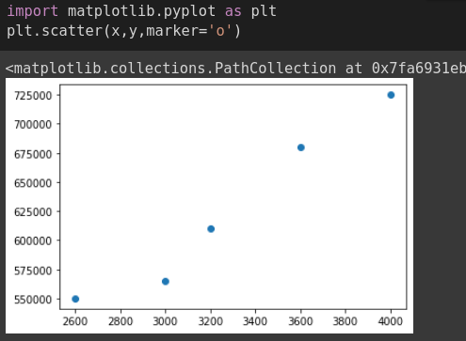

The predicted value for 3300 area is 628715.75342466

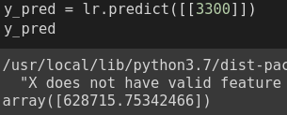

The coefficient for the given dataset model is 135.78767123

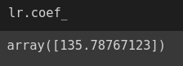

The intercept for the given dataset model is 180616.43835616432

